SVKM’s NMIMS
Mukesh Patel School of Technology Management & Engineering
Computer Engineering Department
Program: B.Tech Integrated Sem V

Course: Basic Data Structures
2024-2025
Experiment No.02
PART A
(PART A : TO BE REFFERED BY STUDENTS)
A.1 Aim:
Introduction to Data Structures and implementation of Arrays

A.2 Prerequisite:
1.Knowledge of different typesof data structures.
2. Fundamental concepts of C\C++.

A.3 Outcome:
After successful completion of this experiment students will be able to
- Identify the need of appropriate selection of data structure
- Explore the effect of appropriate data structure selection.
- Differentiate types of data structure based on their organization of data.
- Enlist the applications of different data structure.
- Implement arrays for the given problem

A.4 Theory:

A.4.1. Inserting a new element in an array
A new element can be inserted at any position of an array if there is enough memory space allocated to accommodate the new element. Some of the elements should be shifted forward to keep the order of the elements.Suppose we want to add an element 93 at the 3rd position in the following array.
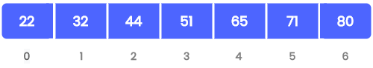
Initial array
After inserting all elements comes after 32 must be moved to the next location to accommodate the new element and to keep the order of the elements as follows.
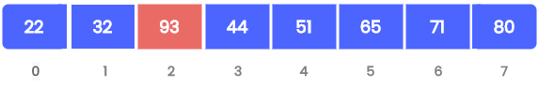

Array after inserting a new element

Deleting an element from an array
Suppose we want to delete element 44 at the 3rd position in the following array.
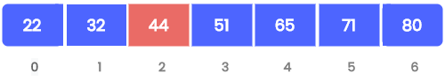
Initial array
After deletion, all elements coming after 44 must be moved to the previous location to fill the free space and to keep the order of the elements as follows.
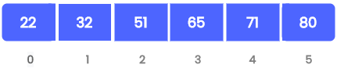
Array after deleting an element

Algorithm
- Find the position of the element to be deleted in the array.
- If the element is found,
Shift all elements after the position of the element by 1 position.
Decrement array size by 1.
- If the element is not found: Print “Element Not Found”

A.5 Procedure/Algorithm:
A.5.1:
TASK 1:
Write a C++ program of array to perform following (1D Array)
- Insertion operation in an arrays.
a) Insertion at the end of array
b) Insertion at specific position in an array
- Deletion operation in an array.
A)Deletion from the end of array
B)Deletion from particular position in array
C) Deleting a particular element in an array

**********************

PART B
(PART B : TO BE COMPLETED BY STUDENTS)
(Students must submit the soft copy as per following segments within two hours of the practical. The soft copy must be uploaded on the Blackboard or emailed to the concerned lab in charge faculties at the end of the practical in case the there is no Black board access available)

Roll No. C172 | Name:
Class : D | Batch :
Date of Experiment: 23/07/24 | Date of Submission 23/07/24
Grade : | Time of Submission:
Date of Grading:

B.1 Software Code written by student:
(Paste your code completed during the 2 hours of practical in the lab here)
Task 1:
i.
a)

#include <iostream>
using namespace std;

int main() {
int i, arr[50], size, item;
cout<<"Enter size of an array: ";
cin>>size;

cout<<"Enter elements in an array: ";
for(i=0; i<size; i++) {
cin>>arr[i];
}

cout<<"Enter item in array to be inserted in end: ";
cin>>item;

arr[size] = item;
size++;
cout<<"Array after Insertion: ";
for(i=0; i<size; i++) {
cout<<arr[i]<<" ";
}
return 0;
}

b)

#include <iostream>
using namespace std;

int main() {
int i, arr[50], size, item, pos;
cout<<"Enter size of an array: ";
cin>>size;

cout<<"Enter elements in an array: ";
for(i=0; i<size; i++) {
cin>>arr[i];
}

cout<<"Enter item in array to be inserted: ";
cin>>item;

cout<<"Enter position of element to be inserted: ";
cin>>pos;

for(i=size; i>=pos; i--) {
arr[i] = arr[i-1];
}

arr[pos] = item;
size++;

cout<<"Array after Insertion: ";
for(i=0; i<size; i++) {
cout<<arr[i]<<" ";
}
return 0;
}

ii.
a)
#include <iostream>
using namespace std;

int main() {
int i, arr[50], size, pos;
cout<<"Enter size of an array: ";
cin>>size;

cout<<"Enter elements in an array: ";
for(i=0; i<size; i++) {
cin>>arr[i];
}

size--;

cout<<"Array after Deletion: ";
for(i=0; i<size; i++) {
cout<<arr[i]<<" ";
}
return 0;
}

b)
#include <iostream>
using namespace std;

int main() {
int i, arr[50], size, pos;
cout<<"Enter size of an array: ";
cin>>size;

cout<<"Enter elements in an array: ";
for(i=0; i<size; i++) {
cin>>arr[i];
}

cout<<"Enter position of element to be deleted: ";
cin>>pos;

for(i=pos; i<size-1; i++) {
arr[i+1] = arr[i];
}
size--;

cout<<"Array after Deletion: ";
for(i=0; i<size; i++) {
cout<<arr[i]<<" ";
}
return 0;
}

c)

#include <iostream>
using namespace std;

int main() {
int i, arr[50], size, item;
cout<<"Enter size of an array: ";
cin>>size;

cout<<"Enter elements in an array: ";
for(i=0; i<size; i++) {
cin>>arr[i];
}

cout<<"Enter element to delete: ";
cin>>item;

for(i=0; i<size; i++) {
if(arr[i] == item) {
for (int j = i; j < size - 1; j++) {
arr[j] = arr[j + 1];
}
}
}
size--;

cout<<"Array after Deletion: ";
for(i=0; i<size; i++) {
cout<<arr[i]<<" ";
}
return 0;
}

B.2 Input and Output:
(Paste your program input and output in following format, If there is error then paste the specific error in the output part. In case of error with due permission of the faculty extension can be given to submit the error free code with output in due course of time. Students will be graded accordingly.)

Task 1:
i.
a)
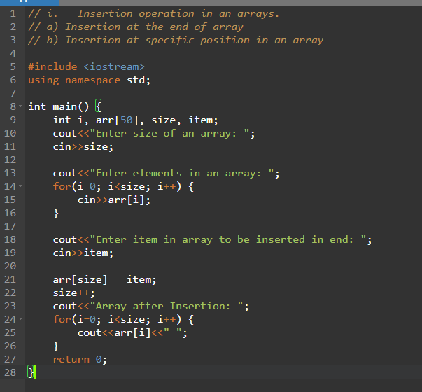

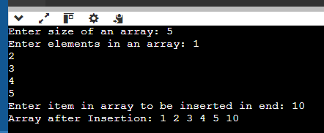
b)
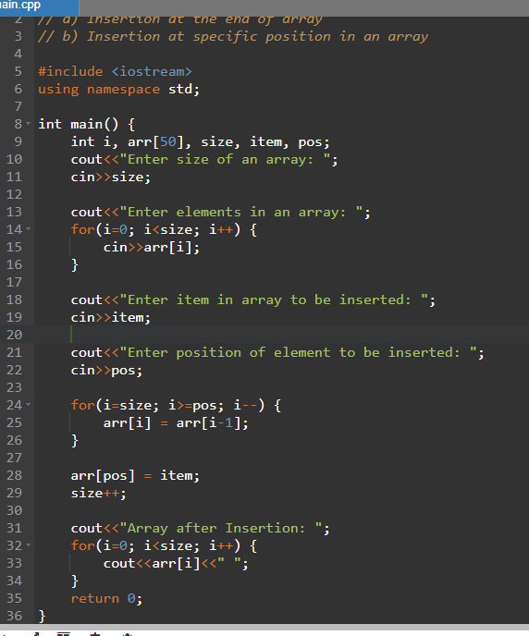
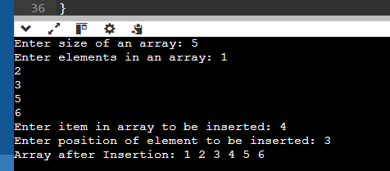

ii.
a)
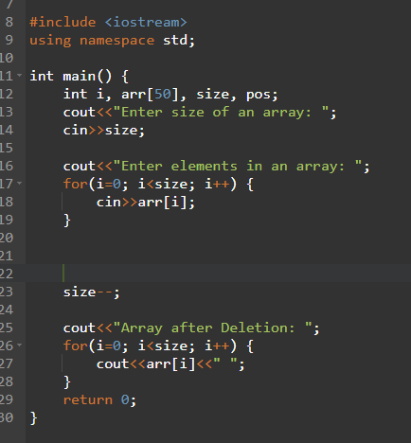
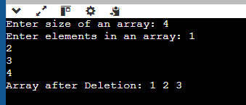

b)
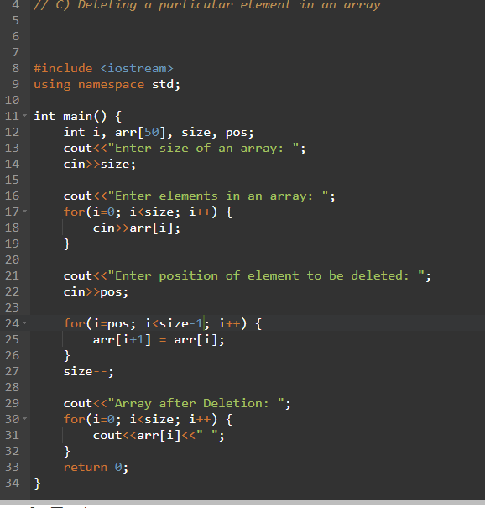
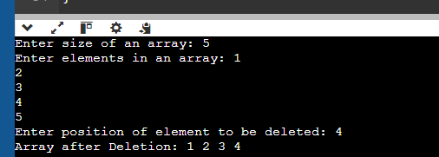

c)
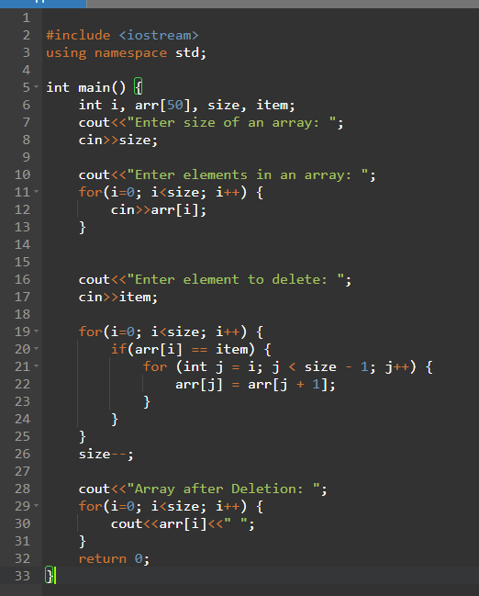
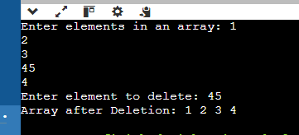

SCENARIO QUESTION ON 1-D ARRAY
IMPLEMENTATION
Q1.
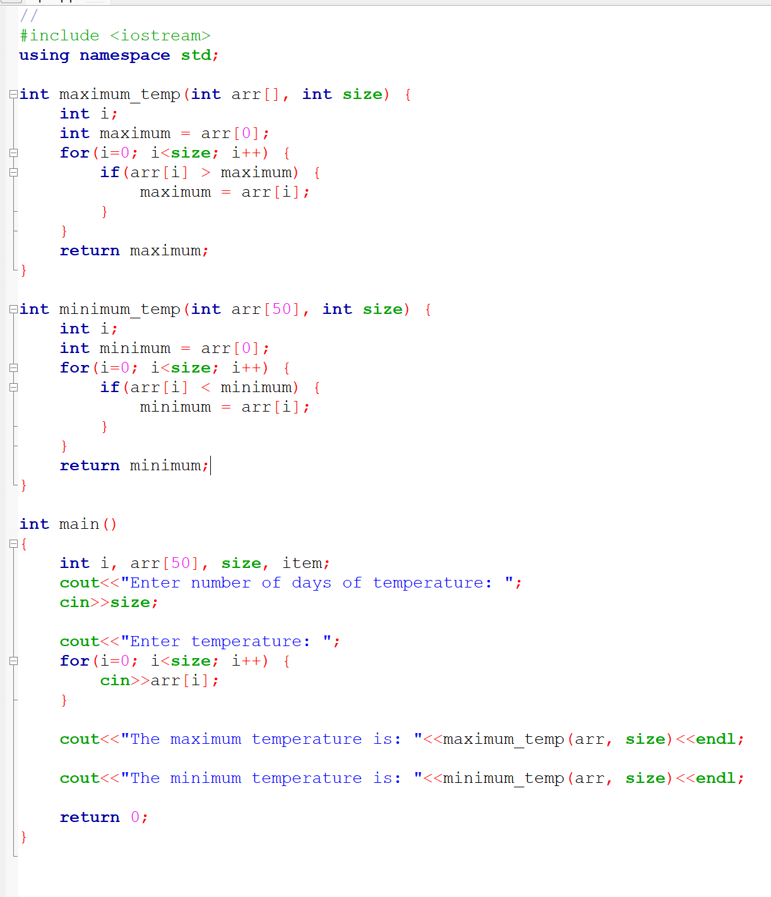
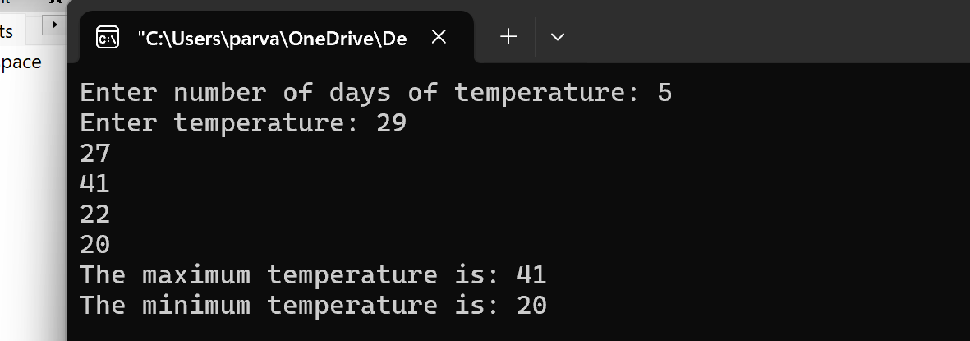

Q2.
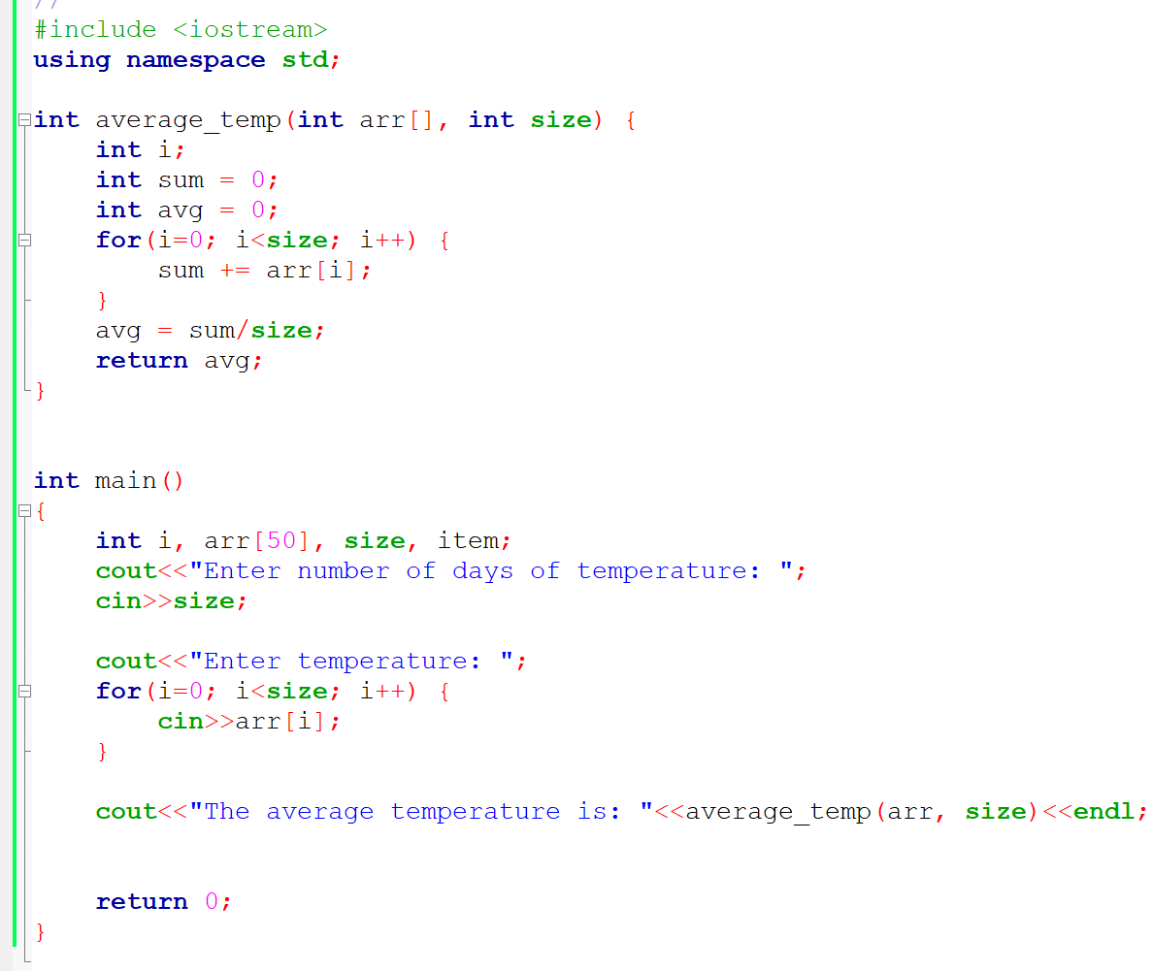
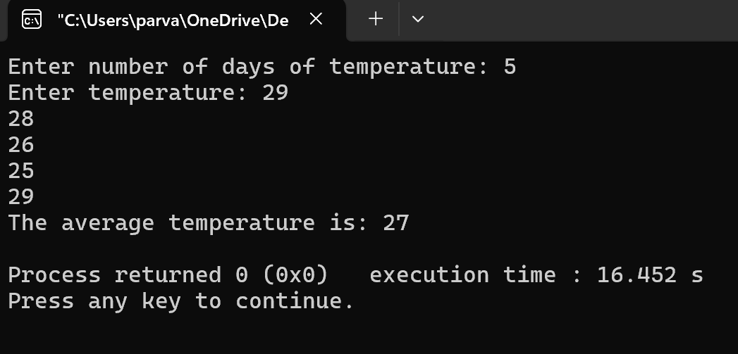

Q3.
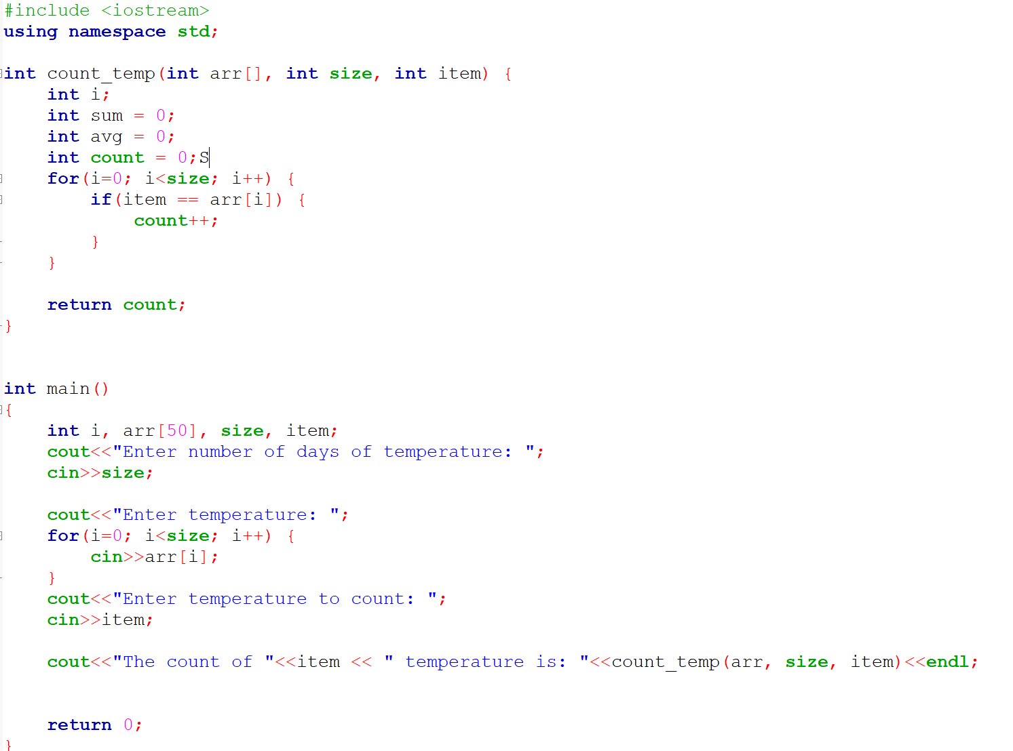
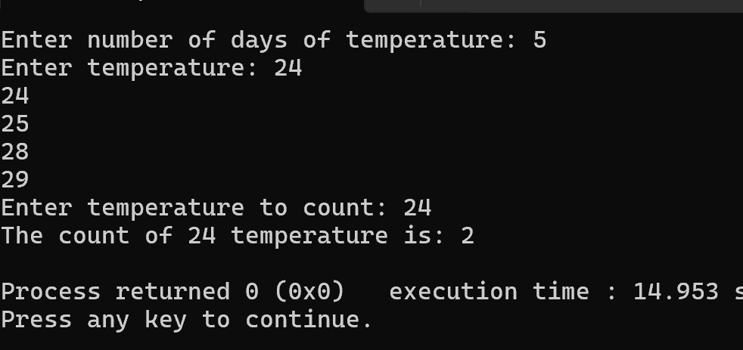

Temperature Monitoring

You are working on a weather monitoring system that records the daily temperatures of a city over a month. You need to perform various operations such as finding the highest and lowest temperatures, calculating the average temperature, and identifying days when the temperature was above a certain threshold.

Questions:

Data Storage:
Q1.How would you use a 1D array to store the daily temperatures?
- To store daily temperatures, I would use a 1D array where each position in the array represents the temperature for a specific day. For example, if the month has 30 days, I would create an array `arr[30]`. The first element `arr[0]` would store the temperature for the first day, `arr[1]` for the second day, and so on up to `arr[29]` for the 30th day.

Q2.Why is a 1D array appropriate for this task?
- A 1D array is appropriate because:
1. Straightforward to Use: It’s easy to understand and use. Each element in the array corresponds to a day, so I can directly access and store temperatures using simple indexing.
2. Fixed Size: The number of days in a month is known, so I can define the array size beforehand, which fits perfectly with a 1D array.
3. Quick Access: I can quickly access any day's temperature using the index, which makes it convenient to perform operations like finding the maximum or minimum temperature.
4. Easy to Iterate: Iterating over the array to perform calculations like average temperature or identifying days with temperatures above a threshold is simple with loops.

Edge Cases:
Q1. How would your functions handle an empty array (e.g., no temperature data available)?
- If there is no temperature data available, the array would be empty. To handle this, I would first check if the size of the array is zero. If it is, I would return a special value or a message indicating that there is no data available. For example, I could return `-1` or print a message like "No temperature data available".

Q2. What would be the output if all temperatures are the same?
- If all temperatures are the same, the functions maximum_temp and minimum_temp will return that same temperature. This is because there will be no value greater than or less than the initial value assigned to maximum and minimum, respectively.
For example, if all temperatures are 25, both maximum_temp and minimum_temp would return 25.

B.3Conclusion:
(Students must write the conclusion as per the attainment of individual outcome listed above and learning/observation noted in section B.3)
B.4Question of Curiosity
(To be answered by student based on the practical performed and learning/observations)

Q1. How an arrays can be declared in the form of an ADT?

************************

